Test # 171
Instrument Name Consistometer
Instrument Type Consistometer
Test Start 05/02/01 09:10
Test Stop 3:00:29
Well ID # KHVALYNSKAYA #3
Customer LUKOIL
Cement Class G
Additives 1.3%TDF-1+Defoamer+0.01%Soda Ash(bwoc)
Cement Mfr DYKERHOFF
BHCT 75
BHST 100
Density 1900
Fluid Loss
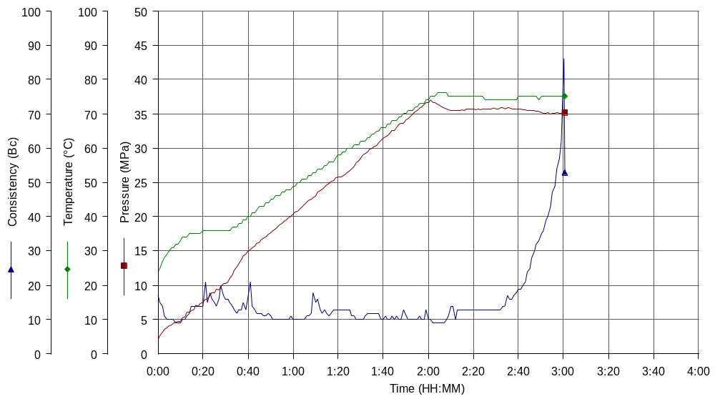
Job Type 340MM CSG

